

MySQL Assignment 1

FSE MySQL Assignment



September 3, 2018

Cognizant

Kolkata

Contents

**DATABASE CREATION SCRIPT:** 1

**TABLE CREATION SCRIPT:** 1

**TABLE INSERT SCRIPT:** 2

**TABLE UPDATE SCRIPT:** 3

**TABLE DELETE SCRIPT:** 3

# **DATABASE CREATION SCRIPT:**

CREATE DATABASE ‘CATALOGUE’;

# **TABLE CREATION SCRIPT:**

CREATE TABLE SUBJECT (

SUBJECT_ID BIGINT(4) NOT NULL AUTO_INCREMENT,

SUBTITLE varchar(30) NOT NULL,

DURATION_IN_HOURS INT(4) NOT NULL,

PRIMARY KEY (SUBJECT_ID)

);

CREATE TABLE BOOK (

BOOK_ID BIGINT(4)NOT NULL AUTO_INCREMENT,

TITLE VARCHAR(30) NOT NULL,

PRICE decimal(8,2) NOT NULL,

VOLUME INT(4) NOT NULL,

PUBLISH_DATE Date NOT NULL,

SUBJECT_ID BIGINT(4) NOT NULL,

PRIMARY KEY(BOOK_ID),

FOREIGN KEY(SUBJECT_ID) REFERENCES SUBJECT(SUBJECT_ID));

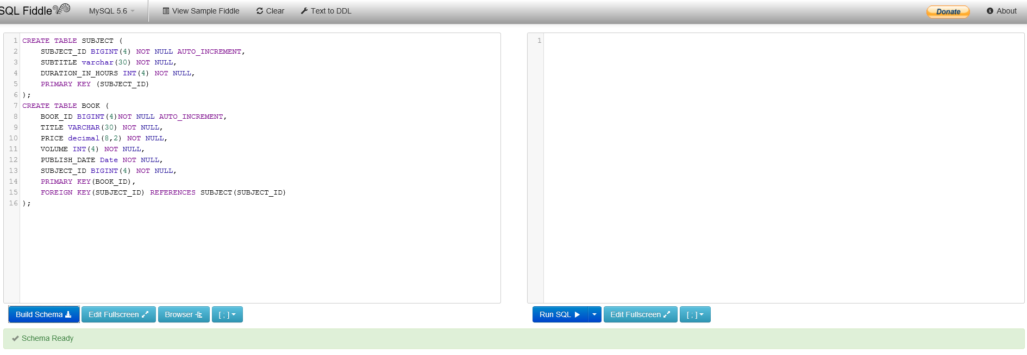

# **TABLE INSERT SCRIPT:**

INSERT INTO SUBJECT VALUES(1,'Fiction',15);

INSERT INTO SUBJECT VALUES(2,'Historical',20);

INSERT INTO SUBJECT VALUES(3,'Poems',20);

INSERT INTO BOOK VALUES(10001,'Pather Panchali',120.50,5,'2015-01-02',1);

INSERT INTO BOOK VALUES(10002,'Prothom Alo',120.50,5,'2015-01-02',2);

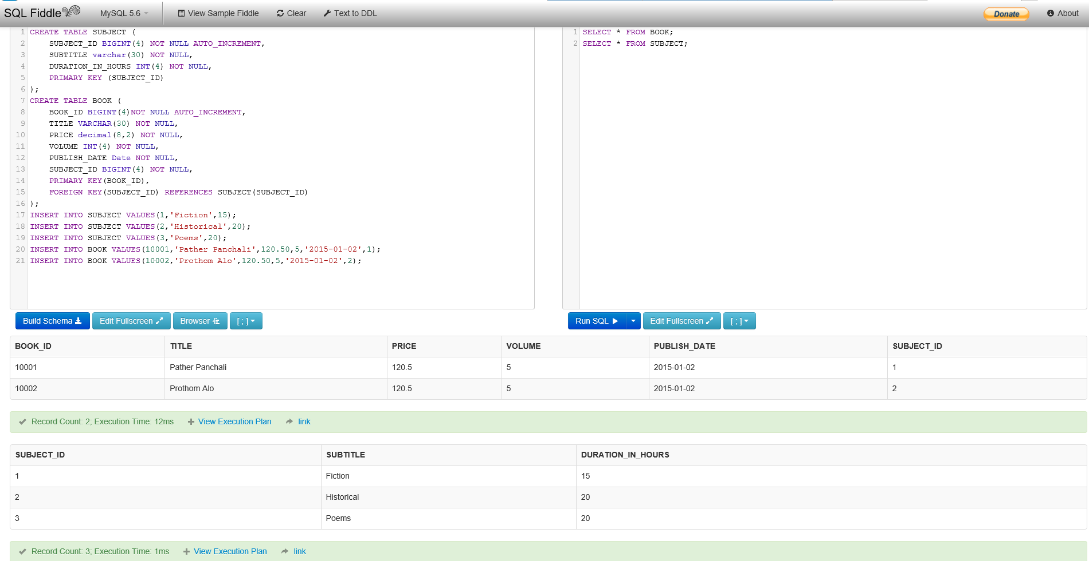

# **TABLE UPDATE SCRIPT:**

UPDATE SUBJECT SET SUBTITLE='Fictional Prose' WHERE SUBJECT_ID=1;

UPDATE SUBJECT SET SUBTITLE='Historical Drama' WHERE SUBJECT_ID=2;

UPDATE BOOK SET TITLE='Charulata' WHERE BOOK_ID=10001;

UPDATE BOOK SET TITLE='Macbeth' WHERE BOOK_ID=10002;

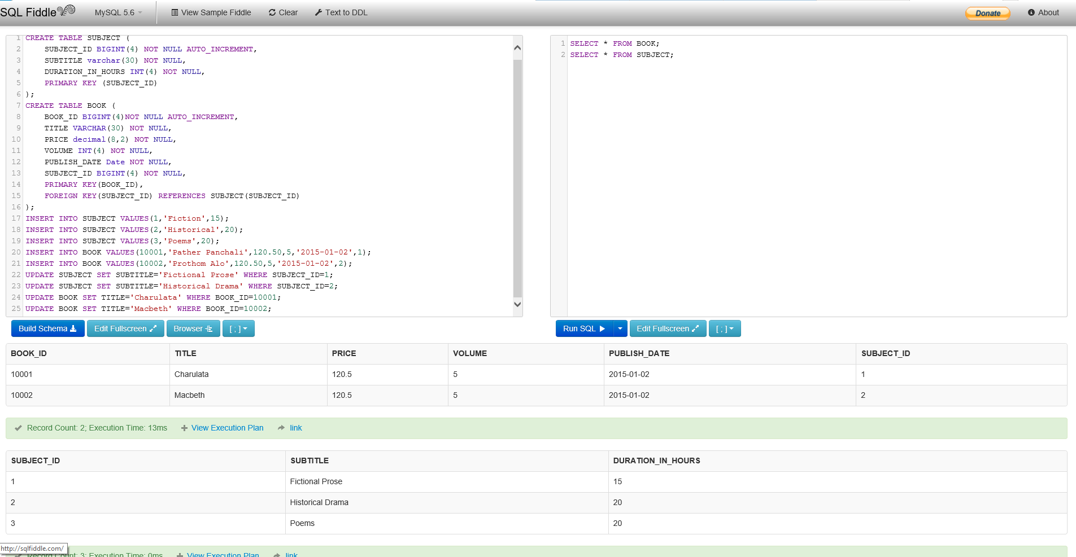

# **TABLE DELETE SCRIPT:**

DELETE FROM SUBJECT WHERE SUBJECT_ID=3;

DELETE FROM BOOK WHERE BOOK_ID=10001;

